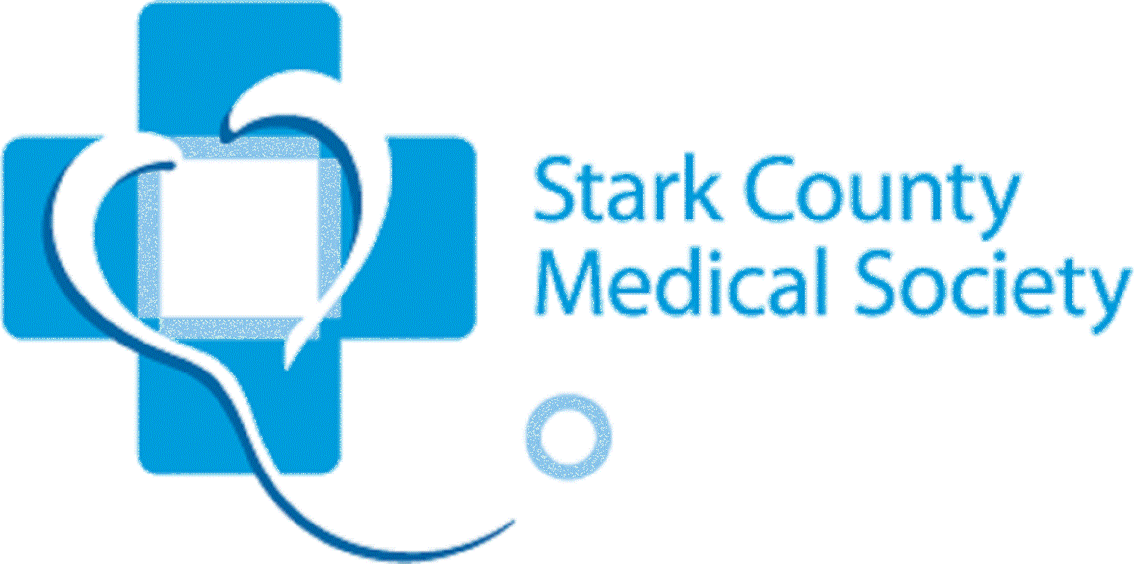
Lunch and Learn Webinar

8/18/2021 11:45 am until 1:00 pm

New cyber training to protect medical providers amid escalating attacks

Responding to the recent spate of cyber-attacks -- disrupting medical & dental practices among other small- to medium-size organizations -- the Stark County Medical Society is offering a virtual training program that will cover new federal recommendations on “five first things to do” to prevent a costly IT breach.

The training is part of our Lunch & Learn program, and will take place on Aug. 18 from 11:45 am until 1:00 pm. Secure your spot today. Cost is only $50.00. Contact Kevin or Taylor at 330.492.3333 to obtain your link. Credit cards are the recommended form of payment.
Due to the critical nature of this presentation, we are extending registrations to members of medical & dental societies across Ohio.

The five recommendations covered in the program relate to:
- Network security
- Software updates
- Data backups
- Incident response plans
- Effective management of IT

The recommendations also reflect security standards under the Health Insurance Portability and Accountability Act (HIPAA). In essence, HIPAA equates to a baseline cybersecurity program -- and good practices. Training is a critical defense against intrusions that breach privacy and IT systems. That’s because training leads to awareness and good daily habits. After all, it only takes one click on a malicious email or link to open a backdoor into even the most secure databases.

Presenter: Diane Evans, Publisher of MyHIPAA Guide, writes extensively on HIPAA compliance issues. Guest viewpoints have appeared in Compliance Today, the peer-reviewed journal of the Health Care Compliance Association (HCCA), The Compliance & Ethics blog, and McKnight's Long-Term Care News. In addition, Diane has authored and conducted accredited training on HIPAA compliance for state and national associations, including HCCA, and for the Cleveland Metropolitan Bar Association.

Secure your spot today. Contact Kevin or Taylor at 330.492.3333 to obtain your link. Credit cards are the recommended form of payment. Cost is only $50.00 per link. No refunds.

