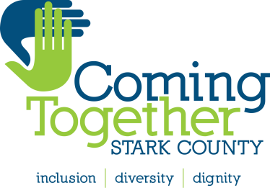

2017 OHIO DIVERSITY AND INCLUSION CONFERENCE
Access & Equity: Intersections in Education and Health
April 21, 2017
8:00 a.m. – 4:15 p.m.
Venue: Stark State College
The Gateway Center
6200 Frank Avenue

The 2017 Ohio Diversity and Inclusion Conference: Access and Equity in Education and Health will examine the interrelationships between education, health and their predictors for successful lives. The conference brings together professionals and laypersons, educators and health practitioners, youth and adults to consider the correlating relationship of education and health to develop an action plan for Stark County and northeast Ohio.
The objectives of the conference aim to:
- present relevant research and strategies aimed at strengthening the connections between health and education;
- explore the Business Case for tackling disparities at health and education’s convergence points to eliminate them;
- include, involve, listen and respond to youth, parents and family participants as well as educators, health professionals, social workers, community-based organization staffs; and,
- develop a responsive, portable action plan that may be implemented in Stark County and northeast Ohio.

Dr. Deena Chisolm
Keynote Speaker
Associate Professor of Pediatrics and Public Health at The Ohio State University and Director of the Nationwide Children’s Hospital Center for Population Health and Equity Research

Accepting Registrations
Early Registration $100 by February 28, 2017, includes a membership to Coming Together Stark County
General Admission - $100 by April 7, 2017
Student discount - $45
Late and Same Day Registration - $150
Contact Coming Together Stark County for Registration Information
Angela Barwick at abarwick@comingtogetherstarkcounty.org
330-454-5880

